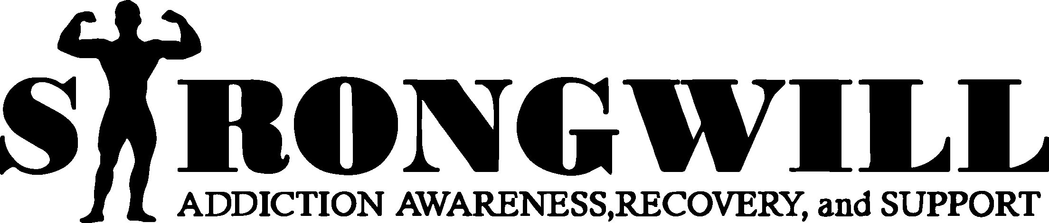
ABOUT US:
StrongWILL was created after my husband, Nathan Brooks, and I, April Brooks, found my brother, Will “Doug” West, after he passed from a heroin overdose in our home. His death forced us to learn more about the opioid epidemic, and the lack of resources and funding in Hampton Roads. We started out with an idea to make a difference; to have a safe haven for those who had similar experiences. We started with a dream to be the change we wanted to see in this world. Our first race funded our 501c3 organization and gave us enough money to donate out as well. Since 2016, we host a fundraising one mile and 5k run / walk in October during the Driver Days event. 2019 is our first year hosting a 1 mile scholarship run / walk during the Touch a Truck event in Driver.
StrongWILL has a mission to focus on addiction awareness, recovery, and support. Every year, we pick a cause associated with our mission, and we fund raise accordingly to try to meet our goal. My board of Nathan Brooks, Sherri Spain, and myself are 100% volunteer.
We take the profits and give them right back into organizations who work hand in hand with addiction.
It’s too late to save my brother, but I can help save others in his honor. It takes a strong mind and strong WILL to fight addiction, but as he would always say “Where there’s a WILL, there’s a way”.
WHO’S ELIGIBLE:
Graduating High School Seniors with a permanent address in Hampton Roads who will attend an accredited college or university in 2019. Applicant must be a U.S. Citizen. (cities include- Chesapeake, Franklin, Hampton, Isle of Wight, Newport News, Norfolk, Portsmouth, Smithfield, Southampton County, Suffolk, Virginia Beach)
HOW TO APPLY:
Applicants must submit 3 copies of a typed essay (not to exceed 1200 words) regarding one of the below topics. (the submitted essay must be the original work of the contestant)
  - Describe how you have fought, or plan to fight, against substance abuse and addiction.
  - What message do you have for current addicts?
  - Discuss your thoughts or ideas on how to help conquer the opioid epidemic in the United States.
To apply for the scholarship, candidate must download, fill out, and submit the application form found at: (will provide link here when on webpage)
The essay must be signed with a full name (both first and last name)
Submit a scanned copy of your completed application form and acceptance letter.

Mail your to the below address before May 17th, 2019:
StrongWILL
PO BOX 7223
PORTSMOUTH, VA 23707
Only one (1) submission per student is allowed.
AWARD:
StrongWILL is offering a minimum of a $500 tuition scholarship. Winner will be announced on June 7th. The scholarship awards may only be used to pay for college tuition and / or education related expenses. Eligibility of the potential winner will be confirmed before scholarship is awarded.
DEADLINE:
Please send your entry to the below address and have it postmarked BEFORE May 17th.
JUDGEMENT:
Applicants will be judged on originality, essay content, style, and research
CONTACT:
You may contact us directly at strongwillevents@gmail.com or driverdays5k@gmail.com

***All applications, including essays and images become the property of StrongWILL and will not be returned***
By entering this essay contest, applicant warrants that he/she meet the eligibility requirements and is submitting original work created by the applicant only***

